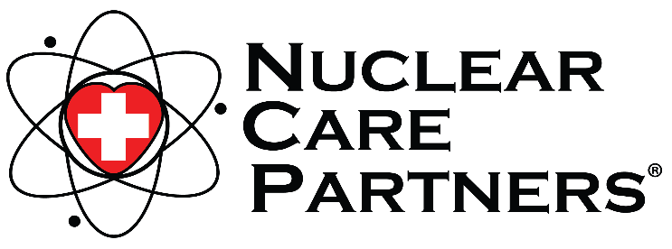
Lori Shanks
Community Outreach Manager
LShanks@NuclearCarePartners.com
Cell Phone: 303-981-5703
Event Phone: 303-225-9396

For Immediate Release
March 16, 2021

Atomic Heroes Luncheon for Rocky Flats Retirees

Arvada, CO – Rocky Flats retirees are invited to a free Atomic Heroes Luncheon hosted by Nuclear Care Partners where they can get help from their local EEOICPA Benefits Specialist, Lori Shanks.

Lori will be available to help answer any questions about the EEOICPA benefits that may be available to Rocky Flats retirees and can help former workers with:
- Prescription Help | - National Jewish Health Screening Review (bring your most recent screening)
- Impairment Ratings
- Reviewing Denied EEOICPA Claims | - White Card Review/Maximize Benefits
The luncheon will be held on two dates: Wednesday, March 31st and Tuesday, April 20th. Former workers can stop by anytime from 11:00 a.m. to 2:00 p.m. at the Arvada American Legion Post 161 located at 6230 W 60th Avenue in Arvada, Colorado 80003.

This is a limited capacity event and all attendees will be required to socially distance and wear a mask. The American Legion will have the room set up specifically for attendees’ safety and Lori will be taking every COVID-19 precaution and has received the COVID-19 vaccine.

As this is a limited capacity event, RSVPs will be on a first-come, first-serve basis. Rocky Flats retirees can call 303-225-9396 to RSVP (please RSVP by March 29th for the March luncheon and by April 16th for the April luncheon). If an over-the-phone appointment is preferred, arrangements can be made upon calling.

“While we know that COVID-19 is still present in our communities, I wanted to host this luncheon to bring some fun to these folks as I know many of us are craving some human connection,” said Lori Shanks, local EEOICPA Benefits Specialist with Nuclear Care Partners. “We have the capacity and COVID-19 protocol to safely get together and I can't wait to connect with these wonderful retirees over lunch!"

About Nuclear Care Partners
Founded in 2011, Nuclear Care Partners proudly provides EEOICPA benefits guidance, advocacy, and no-cost in-home care to former atomic workers who have developed serious illnesses due to their workplace exposure to harmful radiation and toxic chemicals. Our founding belief holds that these brave men and women, who enhanced our nation’s security, deserve kind and compassionate care. As a commitment to quality care, Nuclear Care Partners was the first licensed medical provider enrolled in the Department of Labor program to receive accreditation from Accreditation Commission for Health Care (ACHC). Our passion to serve every community in need has led to expansive growth as we serve hundreds of former atomic workers across the nation. For more information call 303-225-9396 or visit www.NuclearCarePartners.com.

###

